28.30: 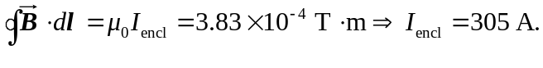
b) 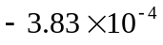 since 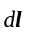 points opposite to 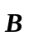 everywhere.

